

**Lab Manual- Java Solid Principal**

**Prepared for**:

**Date:** 18th June 2024

**Prepared by:**

Document Name: Lab Manual **Document Number** SDLab333

**Contributor:**

Contents

1. Solid Principal in Java 3

1.1 Single Responsibility Principle (SRP) 3

1.2 Open/Closed Principle (OCP) 4

1.3 Liskov Substitution Principle (LSP) 6

1.4 Interface Segregation Principle (ISP) 8

1.5 Dependency Inversion Principle (DIP) 9

2. Single Responsibility Principle (SRP) – Example 11

2.1 Explanation: 12

2.2 Compile and Run 12

# Solid Principal in Java

[SOLID principle](https://www.geeksforgeeks.org/solid-principle-in-programming-understand-with-real-life-examples/) is an acronym that stands for 5 key principles in software development:

* **S** – Single Responsibility Principle
* **O** – Open Closed Principle
* **L** – Liskov Substitution Principle
* **I** – Interface Segregation Principle
* **D** – Dependency Inversion Principle

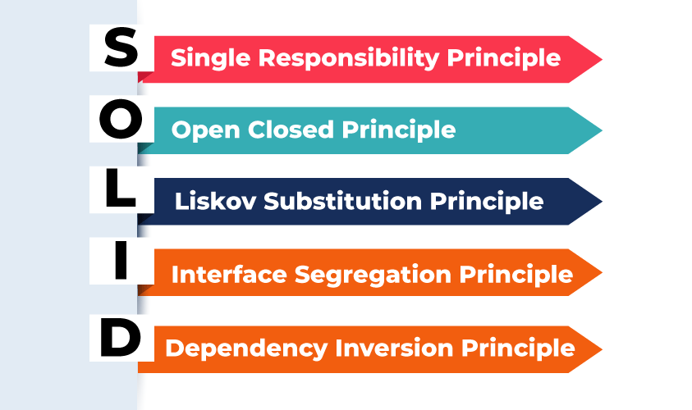

### Single Responsibility Principle (SRP)

**Definition**: A class should have only one reason to change, meaning it should have only one job or responsibility.

**Real-life Example**: Imagine a restaurant.

* **Chef**: Responsible only for cooking food.
* **Waiter**: Responsible only for taking orders and serving food.
* **Cashier**: Responsible only for billing and handling payments.

If a waiter started cooking or a chef started handling payments, it would violate the SRP. Each role has a single responsibility.



### Open/Closed Principle (OCP)

**Definition**: Software entities should be open for extension but closed for modification.

**Real-life Example**: A plug socket.

* The design of a plug socket is fixed and doesn't change. However, you can extend its functionality by plugging in different devices (lamps, chargers, etc.) without modifying the socket itself.

The socket is closed for modification (its design doesn’t change) but open for extension (you can add different devices).



**Definition:** Software entities (classes, modules, functions, etc.) should be open for extension but closed for modification.

**Example:** **Drawing shapes** where we can **add new shapes** ***without changing*** **existing code**.

/* Open/Closed Principle (OCP)

Definition: Software entities (classes, modules, functions, etc.) should be open for extension but closed for modification.

Example: Drawing shapes where we can add new shapes without changing existing code.

*/

// Abstract shape

abstract class Shape {

    abstract void draw();

}

// Circle shape

class Circle extends Shape {

    void draw() {

        System.out.println("Drawing Circle");

    }

}

// Rectangle shape

class Rectangle extends Shape {

    void draw() {

        System.out.println("Drawing Rectangle");

    }

}

// Drawing class

class Drawing {

    private List<Shape> shapes = new ArrayList<>();

    public void addShape(Shape shape) {

        shapes.add(shape);

    }

    public void drawAllShapes() {

        for (Shape shape : shapes) {

            shape.draw();

        }

    }

}

### Liskov Substitution Principle (LSP)

**Definition**: Objects of a superclass should be replaceable with objects of a subclass without affecting the functionality.

**Real-life Example**: Transportation.

* **Superclass**: Vehicle
* **Subclasses**: Car, Bike, Bus

You can substitute any specific type of vehicle for another. If you replace a car with a bike in a scenario where both are supposed to provide transportation, the system (transportation) should still work correctly. If a type of vehicle (like a toy car that doesn't move) doesn't fulfill the same role as a vehicle, it violates the LSP.



**Definition:** Objects of a superclass should be r**eplaceable** with objects of a **subclass** without affecting the functionality.

**Example:** Managing a **collection of birds** where subclasses can replace the superclass.

In this case, **Ostrich violates LSP** because **it can't fly**, leading to an **exception**. To follow LSP,

we need to restructure our classes or logic to handle such cases correctly.

/* Liskov Substitution Principle (LSP)

Definition: Objects of a superclass should be replaceable with objects of a subclass without affecting the functionality.

Example: Managing a collection of birds where subclasses can replace the superclass.

In this case, Ostrich violates LSP because it can't fly, leading to an exception. To follow LSP,

we need to restructure our classes or logic to handle such cases correctly.

*/

class Bird {

    public void fly() {

        System.out.println("Flying");

    }

}

class Sparrow extends Bird {

    @Override

    public void fly() {

        System.out.println("Sparrow flying");

    }

}

class Ostrich extends Bird {

    @Override

    public void fly() {

        throw new UnsupportedOperationException("Ostriches can't fly");

    }

}

public class BirdSanctuary {

    private List<Bird> birds = new ArrayList<>();

    public void addBird(Bird bird) {

        birds.add(bird);

    }

    public void letBirdsFly() {

        for (Bird bird : birds) {

            bird.fly();

        }

    }

    public static void main(String[] args) {

        BirdSanctuary sanctuary = new BirdSanctuary();

        sanctuary.addBird(new Sparrow());

        sanctuary.addBird(new Ostrich()); // This will cause an issue

        sanctuary.letBirdsFly(); // This will fail for Ostrich

    }

}

### Interface Segregation Principle (ISP)

**Definition**: No client should be forced to depend on methods it does not use.

**Real-life Example**: Appliances.

* A kitchen blender and a vacuum cleaner both operate using electricity. However, they have different interfaces: a blender might have buttons for speed settings and pulse, while a vacuum cleaner might have settings for suction power.

If you were forced to use a common interface for all appliances, you would have to include irrelevant methods for each device. By having separate, specific interfaces, each appliance only uses the methods it needs.

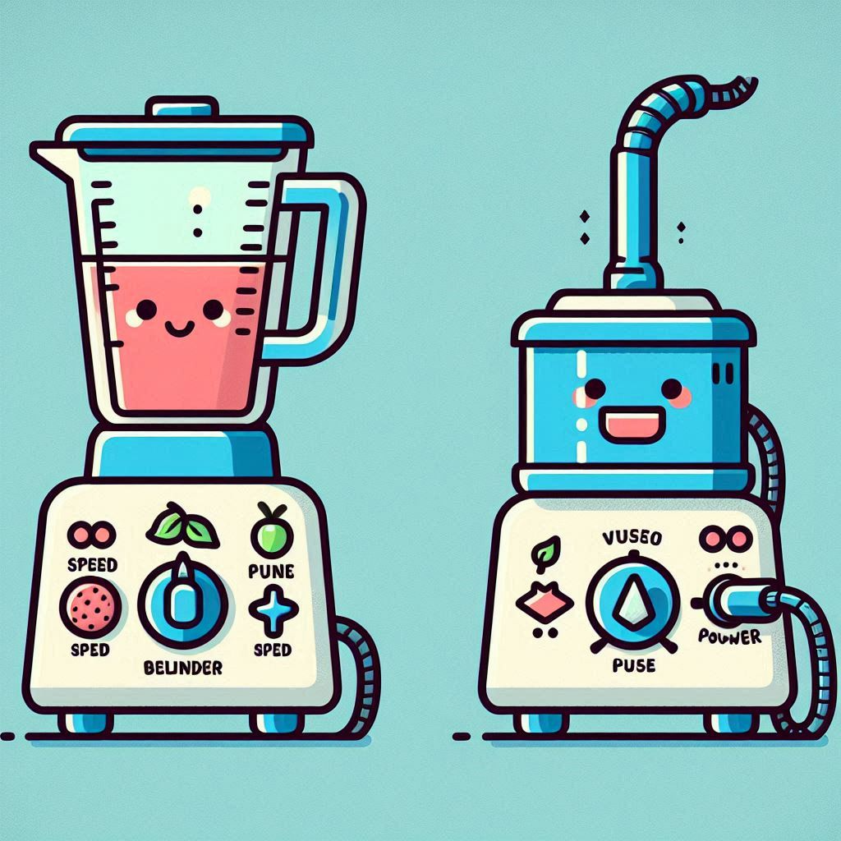

**Definition:** No client should be forced to depend on methods it does not use.

**Example:** **Separate interfaces** for different functionalities of a printer.

interface Printer {

    void print(Document document);

}

interface Scanner {

    void scan(Document document);

}

class Document {}

// Implementing both interfaces

class MultiFunctionPrinter implements Printer, Scanner {

    public void print(Document document) {

        System.out.println("Printing document");

    }

    public void scan(Document document) {

        System.out.println("Scanning document");

    }

}

// Implementing only the Printer interface

class SimplePrinter implements Printer {

    public void print(Document document) {

        System.out.println("Printing document");

    }

}

### Dependency Inversion Principle (DIP)

**Definition**: High-level modules should not depend on low-level modules. Both should depend on abstractions. Abstractions should not depend on details. Details should depend on abstractions.

**Real-life Example**: A remote control and various devices.

* **High-level module**: Remote control
* **Low-level modules**: TV, air conditioner, stereo system

Instead of the remote control being designed specifically for each device, it uses an abstract interface like IR (infrared) or Bluetooth. Each device (TV, air conditioner, etc.) implements this interface. The remote control does not need to know the details of each device; it just sends signals via the abstract interface.

By using this abstraction, you can use the same remote control for different devices without redesigning it for each specific one.

Bottom of Form

**Definition:** High-level modules should not depend on low-level modules.

Both should depend on abstractions. Abstractions should not depend on details. Details should depend on abstractions.

**Example:** Using an interface for switching a device on and off.

By using the **Switchable interface**, the **ElectricSwitch class** does not depend on the specific

implementations of devices, adhering to the Dependency Inversion Principle.

interface Switchable {

    void turnOn();

    void turnOff();

}

class LightBulb implements Switchable {

    public void turnOn() {

        System.out.println("LightBulb is turned on");

    }

    public void turnOff() {

        System.out.println("LightBulb is turned off");

    }

}

class Fan implements Switchable {

    public void turnOn() {

        System.out.println("Fan is turned on");

    }

    public void turnOff() {

        System.out.println("Fan is turned off");

    }

}

class ElectricSwitch {

    private Switchable device;

    public ElectricSwitch(Switchable device) {

        this.device = device;

    }

    public void operate(boolean on) {

        if (on) {

            device.turnOn();

        } else {

            device.turnOff();

        }

    }

}

# Single Responsibility Principle (SRP) – Example

Here's a very simple example in Java that follows the Single Responsibility Principle (SRP). This principle states that a class should have only one reason to change, meaning it should have only one job or responsibility.

Let's create a program that handles employee management, where we separate the responsibilities of handling employee data and calculating their salary.

1. **Employee class**: Responsible for storing employee data.
2. **SalaryCalculator class**: Responsible for calculating the salary of the employee.

**Employee.java**

// Employee.java

public class Employee {

    private String name;

    private int hoursWorked;

    private double hourlyRate;

    public Employee(String name, int hoursWorked, double hourlyRate) {

        this.name = name;

        this.hoursWorked = hoursWorked;

        this.hourlyRate = hourlyRate;

    }

    public String getName() {

        return name;

    }

    public int getHoursWorked() {

        return hoursWorked;

    }

    public double getHourlyRate() {

        return hourlyRate;

    }

}

**SalaryCalculator.java**

// SalaryCalculator.java

public class SalaryCalculator {

    public double calculateSalary(Employee employee) {

        return employee.getHoursWorked() * employee.getHourlyRate();

    }

}

**Main.java**

// Main.java

public class Main {

    public static void main(String[] args) {

        Employee employee = new Employee("John Doe", 40, 20.0);

        SalaryCalculator salaryCalculator = new SalaryCalculator();

        double salary = salaryCalculator.calculateSalary(employee);

        System.out.println("Salary of " + employee.getName() + ": $" + salary);

    }

}

### Explanation:

* **Employee.java**: This class is only responsible for storing employee data.
* **SalaryCalculator.java**: This class is responsible for calculating the salary based on the employee data.
* **Main.java**: This is the entry point of the program, which creates an instance of Employee and SalaryCalculator, and prints the calculated salary.

This way, each class has a single responsibility, making the code easier to understand and maintain.

### Compile and Run

**javac *.java**

**java Main**

